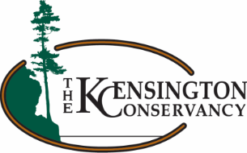
TKC Poker Run
Your Name:

Contact Info:

Pledge Form

All proceeds go towards The Kensington Conservancy’s conservation efforts in the Desbarats area!
Name | Address | Email for a receipt | Amount Pledged | Collected  (Y/N) | Phone Number

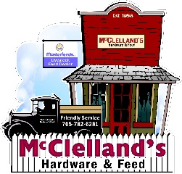
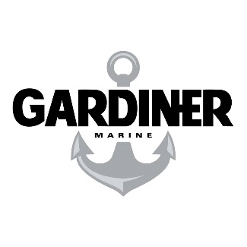
Please turn this pledge form in on the morning of the TKC Poker Run. A minimum of $10 is required to participate. There will be a prize for whoever pledges the most money!

